**Hops House Microbrewery: Competitive Analysis**

Trey Gehring

**Competitors Evaluated:**

Hoppin’ Frog Brewery: http://www.hoppinfrog.com

Rockmill Brewery: http://www.rockmillbrewery.com

Ohio Brewing Company: http://www.ohiobrewing.com

Royal Docks Brewing Co: http://www.royaldocksbrewing.com

Forest City Brewery: http://www.forestcitybrewery.com/

**Summary:** Competitor websites vary but the most successful designs were simple and succinct. The feel of a brewery is successful communicated by suggestions of rustic wood and earth tones. Trend towards a handmade feel versus a more sterile business feel.

**Common Features:** The websites tended to have similar content including a beer list with descriptions and label images, a menu of food items, a calendar of events, links to social media accounts, event rental information, and contact information.

**Problems to avoid:** Fully responsive design is a necessity. Some of the websites were not responsive or became boring and text-filled on small screens.

**Recommendations and Strategy:**

The tone of the website will focus on the important fact that Hops House is a local business deeply connected with the community. Emphasis will be placed on the one-of-kind beers. An interactive event calendar will keep customers informed on upcoming events to help draw in new customers and keep existing customers coming back. The brew of the month will be profiled and feature prominently and will include pairing information for the brew and applicable menu items, as well as reminding customers of growler services and suggesting how to incorporate the brew into seasonally relevant social gatherings (memorial day bbq, Christmas, Fourth of July, etc.). Contact form and email list signup will keep customers aware in contact. Email list specials will encourage sign-up and include brew of the month updates and discounts and announce new menu items.

**Hoppin' Frog Brewery**

http://www.hoppinfrog.com

brewery and tasting room in Akron, OH.

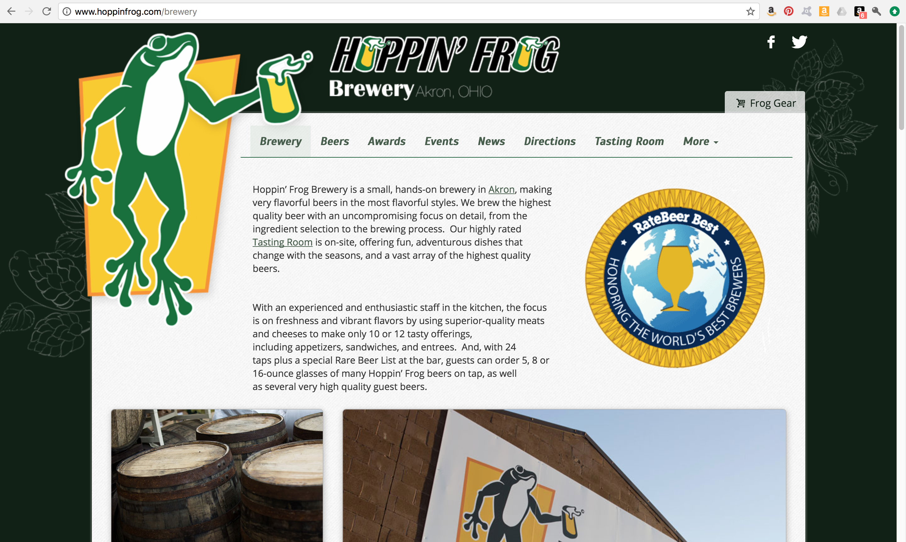

**Logo-** simple 3-color tree frog with a pint glass of beer. Logotype with the same glass of beer replacing the *O*s in the name in the top banner of the site. Sans-serif logotype.

**Colors-** multiple greens and yellows, white, black.

**Navigation-** Horizontal navigation bar. Hover effect- transparent green block overlay. Active page has subtle green box around it.

Navigation Labels:

* Brewery
* Beers
* Awards
* Events
* News
* Directions
* Tasting Room
  + Tap List
  + Menu
* More
  + Distributors
  + Careers
  + Contact Information

**Social Media Links-** simple white Facebook and Twitter logos at top right of page. More are available for the tasting room.

**Mood and Tone-** Casual feel to website, with frog drinking beer logo. However, the Brewery page takes a slightly different tone. Seems to target an audience with discerning taste and *"For those who search for this long lost, undying commitment to the very best, let it be known that one beer will not be compromised - Hoppin'* Frog!" Otherwise the site has a playful casual nature.

**Layout and Structure-** Overall, the website is disjointed. There are multiple templates at work on different pages. It is as though the Brewery pages and the Tasting Room pages were created separately, but have connections to each other via the top horizontal navigation menu. Navigation becomes problematic because the navigation elements are in different places on each of the page templates. Pages are mostly single vertical content stacks. Tabbed panel for displaying different categories of beer.

**Features-**

Upon entry to the site, the user is asked to confirm that they are 21+ (of legal drinking age).

Full listing of the available brews using a tabbed panel.

Entire page dedicated to the awards they have received.

Calendar of events and drink specials.

Inset Twitter feed

Mailing list subscription form

Web Store that sells tap handles, clothing and accessories, glassware, gift cards, and other gift items.

**Responsiveness-** Pages are somewhat flexible. Elements scale with change in window/screen size. However once the page is size down to a breakpoint of 768px or smaller, the page becomes extremely simplified and plain. Even the logo completely disappears. The typical phone screen size seems to be an afterthought. When viewing on a phone it becomes mostly large blocks of text.

**Strengths-** Approachable, contains lots of information (too much?).

**Weaknesses-** Confusing navigation because of the dual template problem. Loses most design interest when viewed on a mobile device. Lots of text. Very large navigation menu. Too many pages. Could be condensed.

**Rockmill Brewery**

www.rockmillbrewery.com

brewery and tasting room in Lancaster, OH. Also have Rockmill Tavern in Columbus, OH, which is a separate restaurant serving their brews.

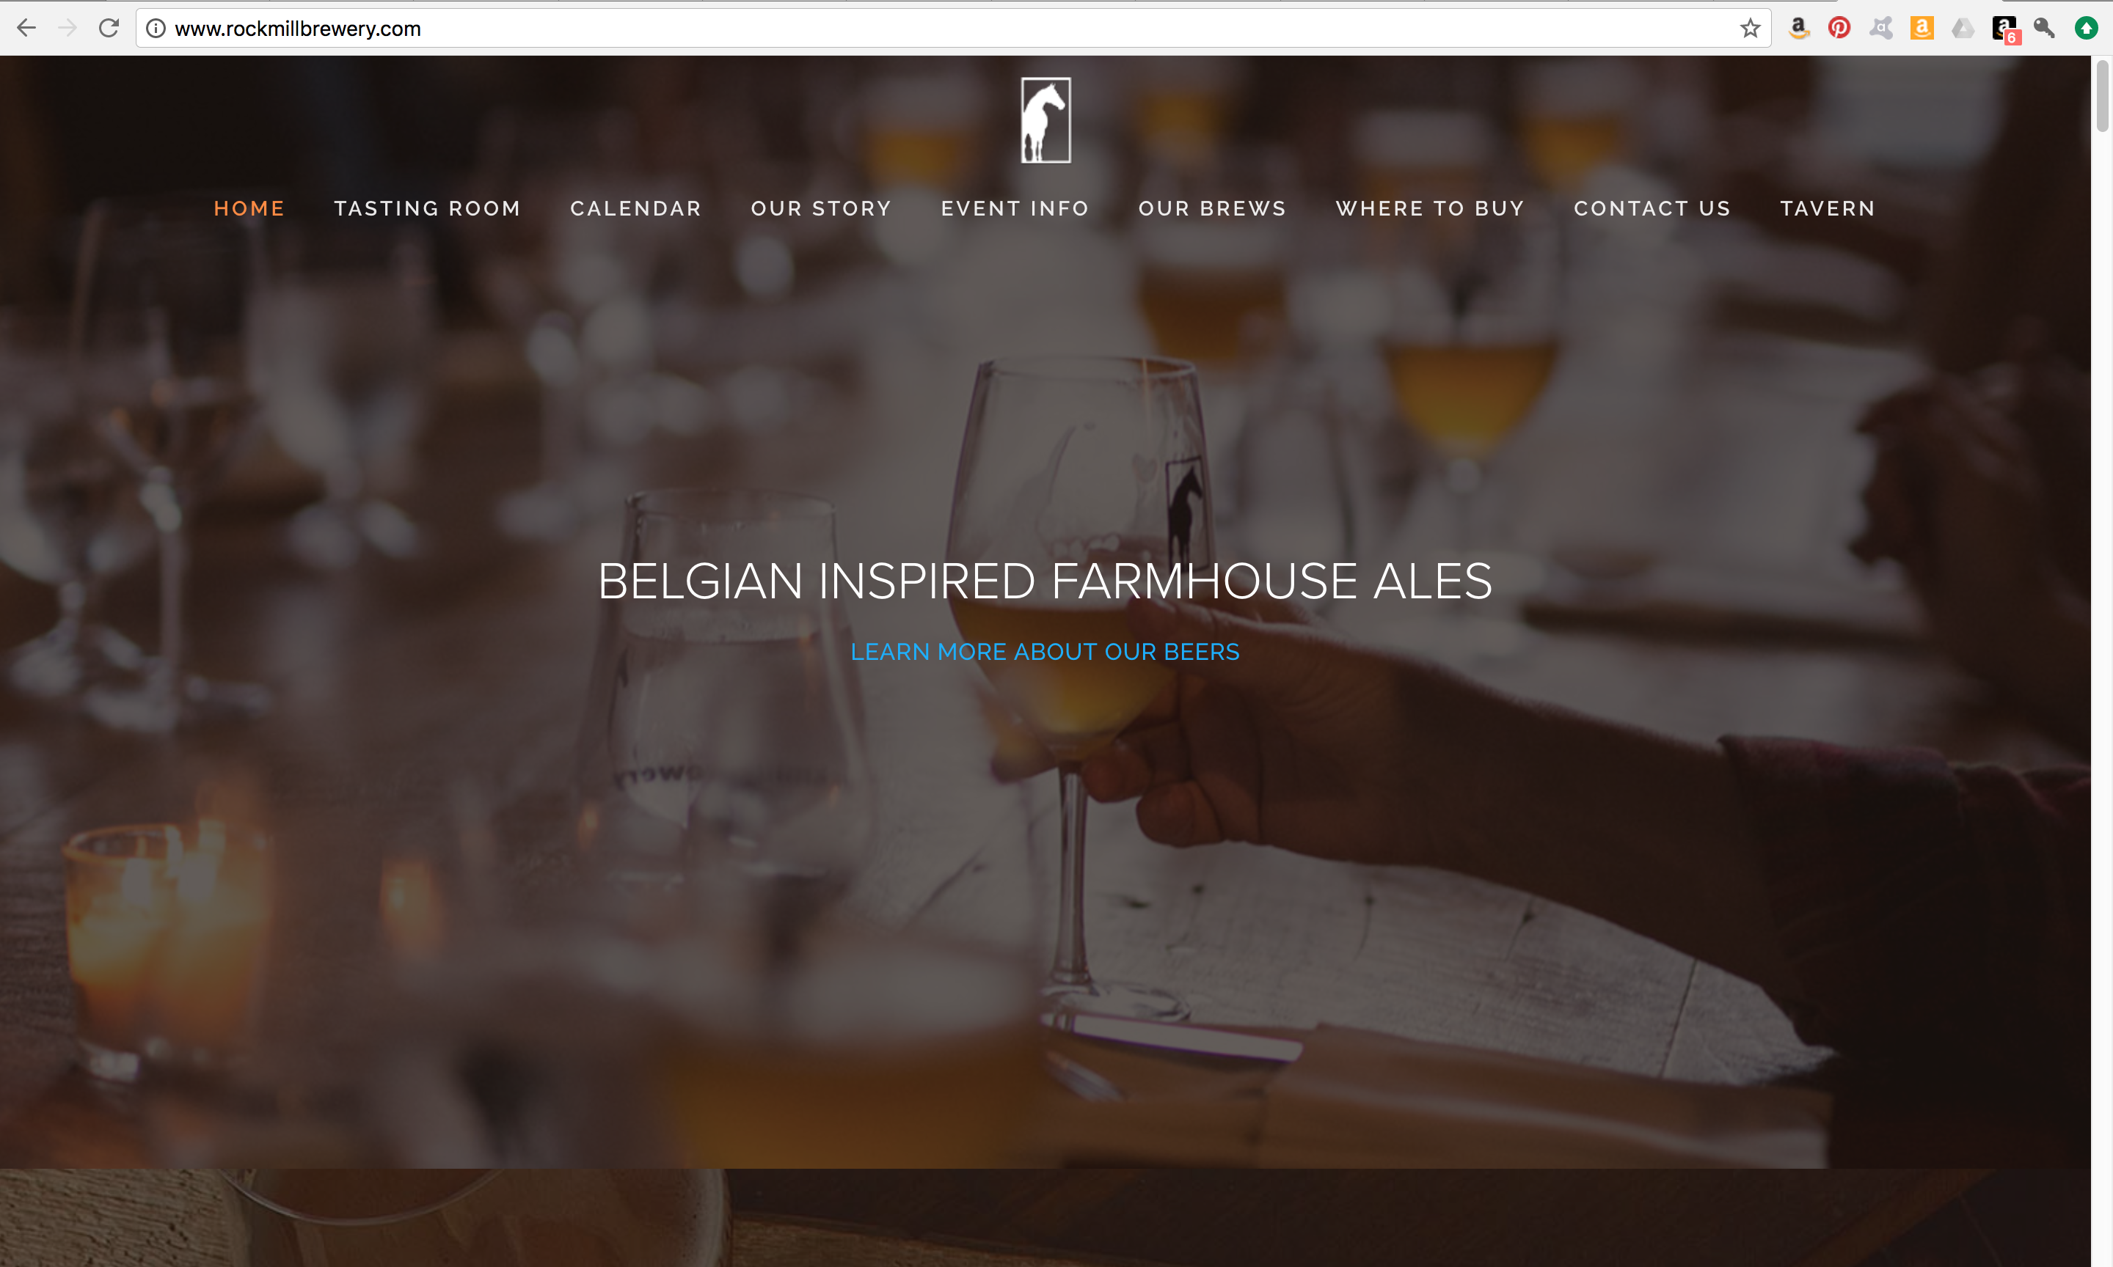

**Mood and Tone-** Elegant and calm

**Logo-** white or black horse silhouette in rectangular box (doorframe-like)

**Colors-** photo backgrounds are warm dark and earthy, text- white, orange, black, blue links.

**Navigation-** horizontal navigation at top of page that at a certain point in scrolling pulls down like a drawer from the top of the page and follows along as you scroll further down. Scroll effect to navigate you to the parts of the page that the links bring you to (see "Layout and Structure").

Navigation Labels:

* Home
* Tasting Room
* Calendar
* Our Story
* Event Information
* Our Brewery
* Where to Buy
* Contact Us
* Tavern

**Social Media Links-** Instagram and Facebook icons in the footer of page

**Layout and Structure-** The entire site is one single page divided into separate sections as you scroll. All of the navigation links actually just take you to certain points in the single page. Hard lines between the sections such as the photo backgrounds in the first two portions, or the alternating grey and white sections to denote each "page."

**Features-**

Calendar of Events

Video profile of the brewery

Inset tiling Instagram feed

Grid tiling of beer selection (label images)

Contact form

**Responsiveness-** Scales well. Some text seems to be a bit too large and fills too much space and detracts from the simple elegant feel of the site. Because the entire website is one page, when the page is elongated for mobile viewing, it becomes an extremely long webpage

**Strengths-** Simple and elegant. Establishes a clear mood for the company. Provides needed information in a consistent way. navigation is straightforward. Site scales well, is responsive.

**Weaknesses-** Single page scroll website becomes problematic with so many sections ("pages").

**Ohio Brewing Company**

http://www.ohiobrewing.com

brewery and "brewpub" in Akron, OH.

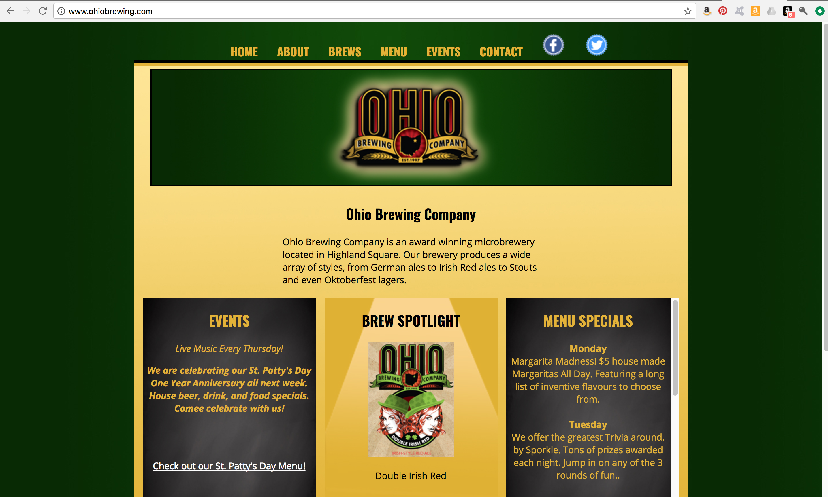

**Mood and Tone-** Casual, Hometown, Inexpensive

**Logo-** Logotype with Ohio as the most prominent word. Features a silhouette of Ohio with a star over the city of Akron. Also features stalks of wheat. Logo is red, black, and gold.

**Colors-** Greens and yellows, black, Text: yellow, black, white links.

**Navigation-** Horizontal navigation section at the top of the page. Heavy yellow text on a green background.

Navigation Labels:

* Home
* About
* Brews
* Menu
* Events
* Contact

**Social Media Links-** top right white logos in bottle-cap frames.

**Layout and Structure-** Blocky layout, lots of solid areas and clearly defined borders. Metallic effect buttons as a secondary navigation directly above the footer. Three sections aligned horizontally on the main page, each a preview to a corresponding page of the site: events, brews, menu. Page of brews with images of labels.

**Features-** explanation of the brewing process, calendar of events, menu, contact form.

**Responsiveness-** No responsive qualities. Static site.

**Strengths-** not an overwhelming amount of information, to the point.

**Weaknesses-** lacks a strong design aesthetic, overall not an attractive website, cheapens the brand.

**Royal Docks Brewing Co.**

http://www.royaldocksbrewing.com

Brewery and Brewpub in Canton, OH.

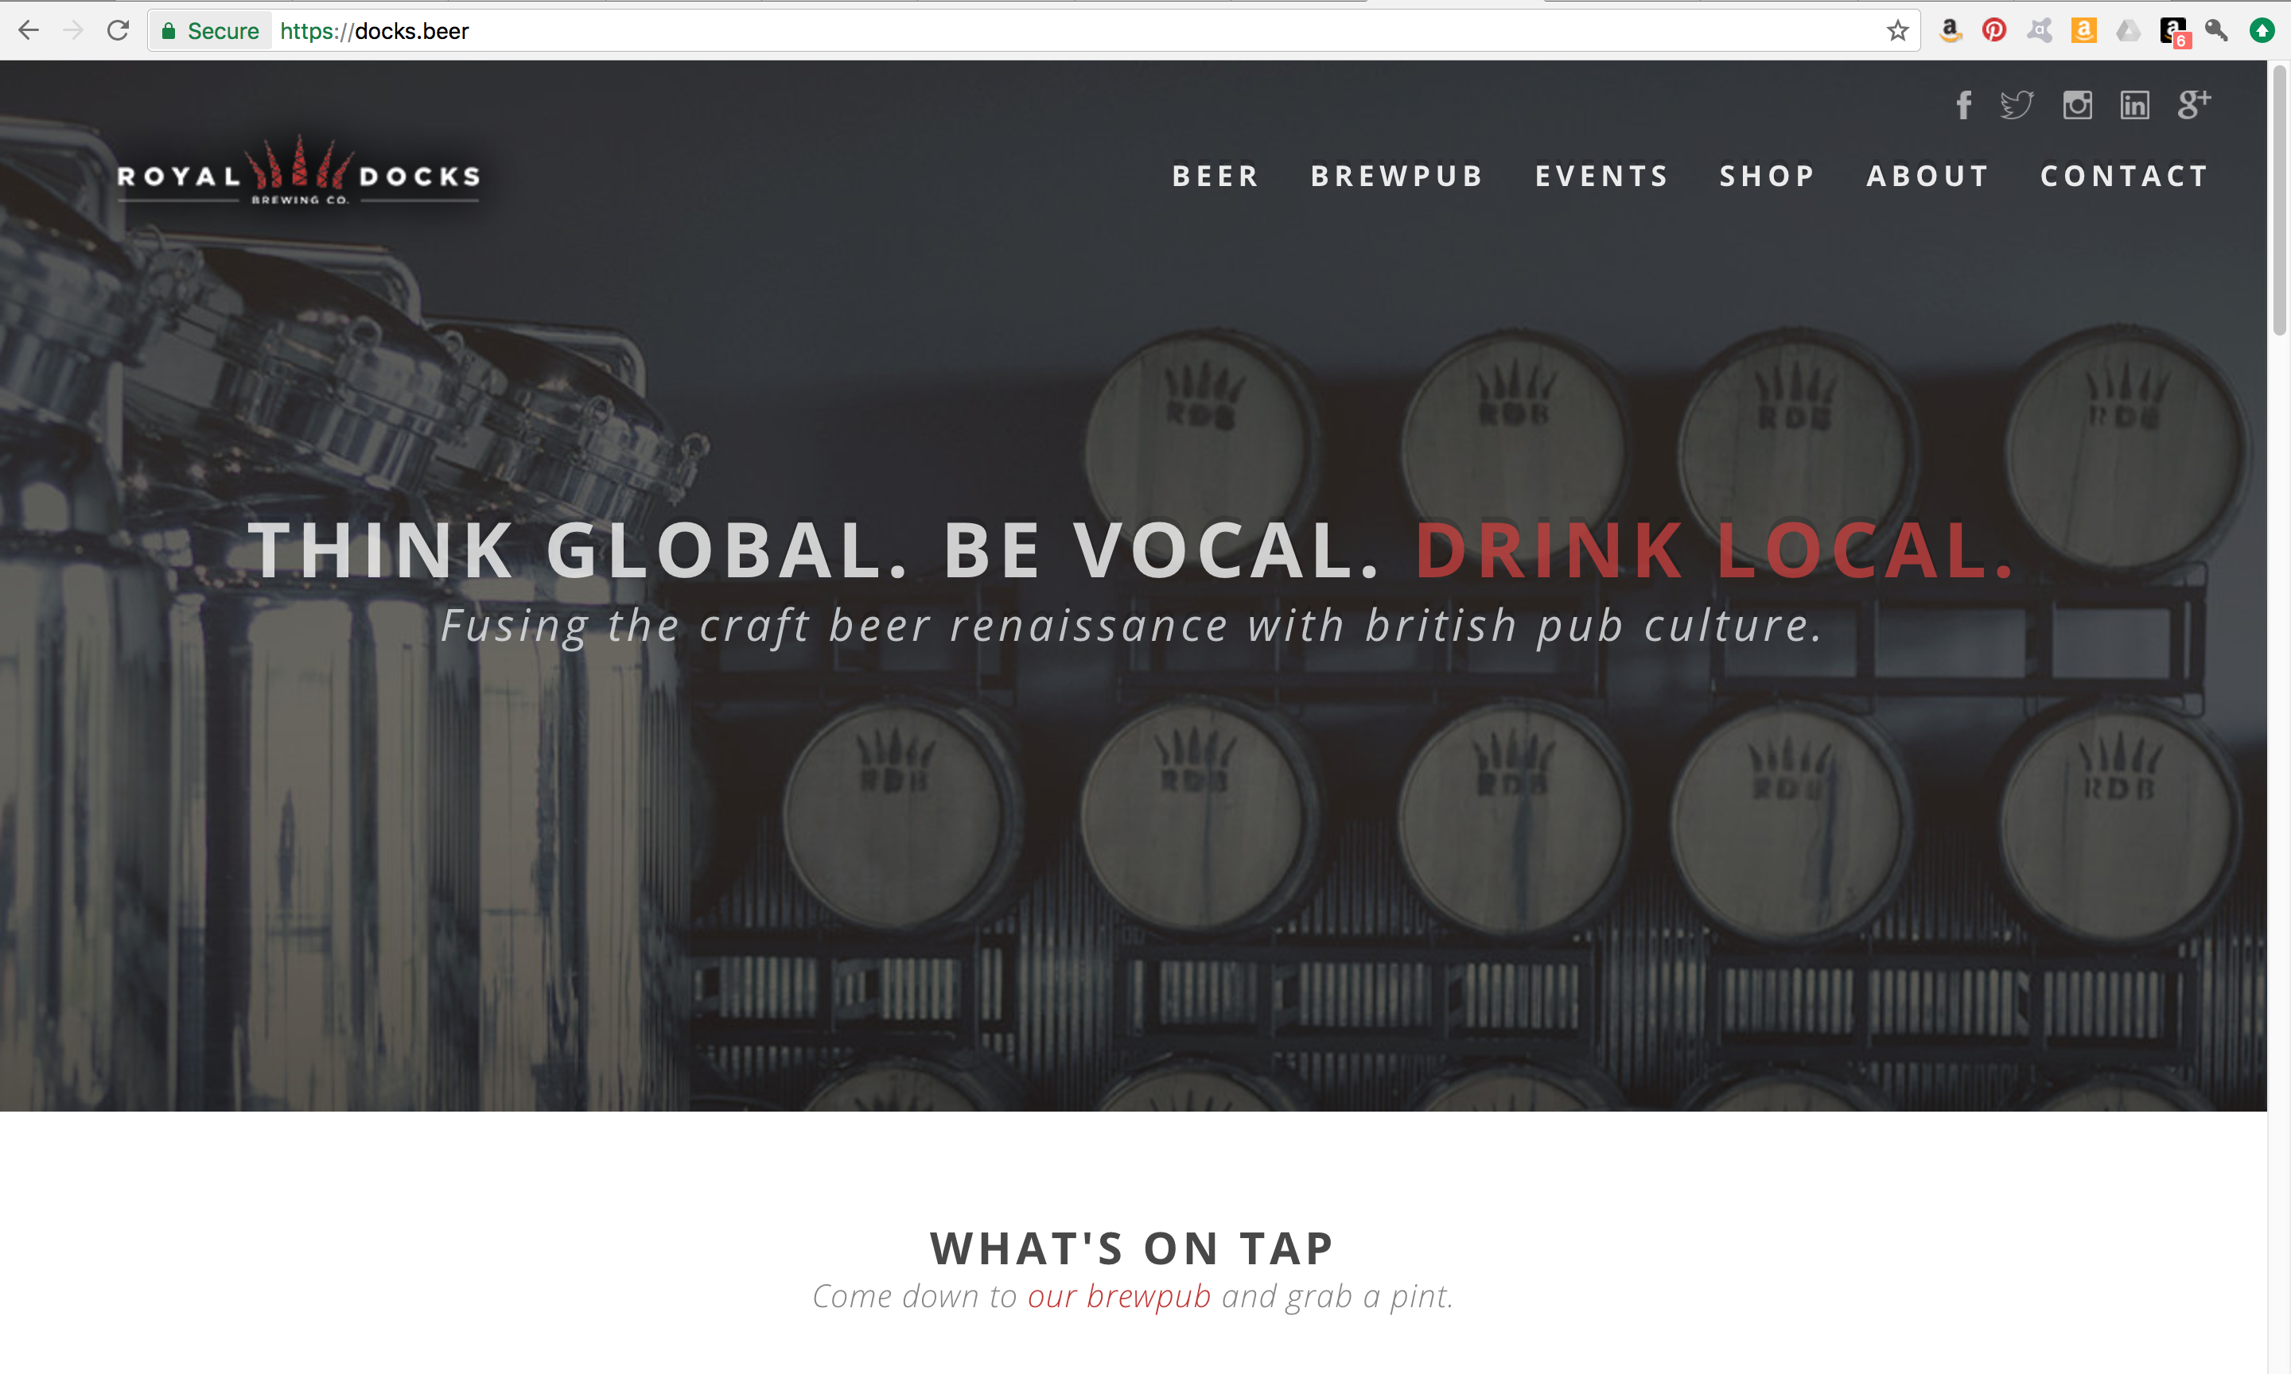

**Mood and Tone-** *"Fusing the craft beer renaissance with British pub culture."* Simple, clean aesthetic, lots of space to breathe, consistency from page to page. Metal and wood feel.

**Logo-** Geometric, red, crown-like logo.

**Colors-** Red, white, black, grey. Text: charcoal grey, black, medium grey, red.

**Navigation-** Horizontal navigation bar in header. Navigation menu becomes a dropdown menu at small screen size. Additional submenus upon hover when on larger screen with a mouse.

Navigation Labels:

* Beer
* Brewpub
* Events
* Shop
* About
* Contact

**Social Media Links-** light grey logos at top right, above the navigation menu.

**Layout and Structure-**

**Features-** mailing list

keg sales contact information

web store selling branded merchandise, special paid event booking payments, giftcards.

calendar of events

giftcard sales and balance checker

inset map

**Responsiveness-** Fully responsive, adapts to multiple screen sizes. Seems to have been built with mobile first in mind.

**Strengths-** Strongest of the websites analyzed. Fully responsive. Mobile first design. Appropriate amount of information, not overwhelming. Inviting without feeling cheap. Balanced amount of images and text.

**Weaknesses-** Something awkward about the way the fold on the landing page lands. Webstore feels poorly integrated to the website. Partially integrated but functioning like its own website in other ways.

**Forest City Brewery**

http://www.forestcitybrewery.com/

Brewery and tasting room with a small selection of appetizers and a BYO food policy.

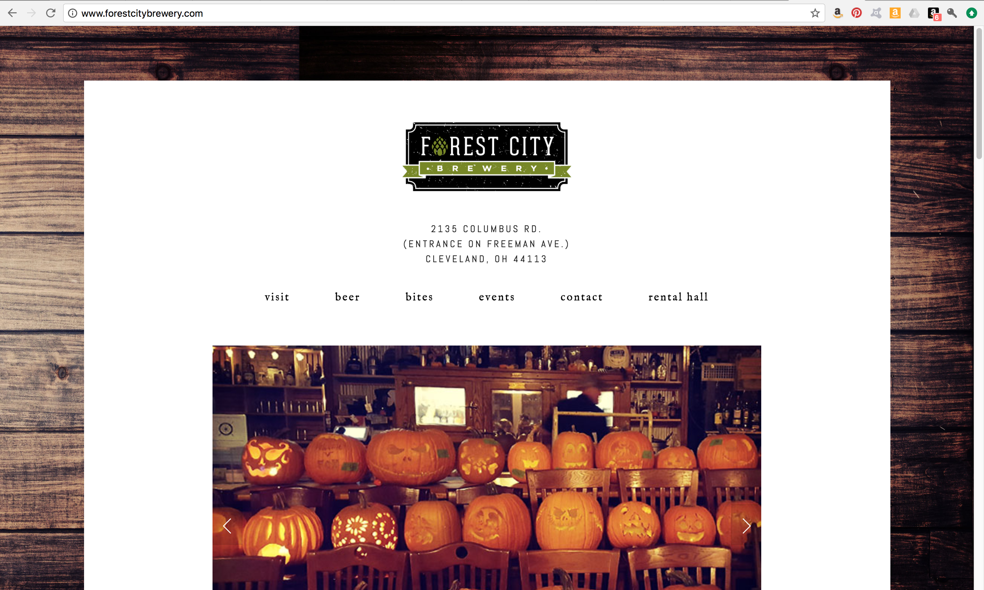

**Mood and Tone-** Simple, relaxing.

**Logo-** Logotype with a simple hop illustration replacing the *O*. Black distressed "label" with green banner.

**Colors-** black, "hoppy" green, white. Text: black, dark grey, green links.

**Navigation-** Horizontal at top of page below the header containing the logo. Becomes a drop down menu at smaller screen size.

Navigation Labels:

* visit
* beer
* bites
* events
* contact
* rental hall

**Social Media Links-** White logos in green rounded boxes in the footer.

**Layout and Structure-** Simple white pages with single columns of text and images. Image carousels with mid-sized thumbnails of each image below the large active image.

**Features-**

promotional video

calendar of events

link to rate the brewery's beer

event contact form

menu

**Responsiveness-** fully adaptive, bit of a glitch in the layout of the navigation menu at a mid-sized breakpoint.

**Strengths-** Simple clean design, easy to navigate. Relaxed yet professional.

**Weaknesses-** responsive menu glitch. Verging on overly simplistic.